
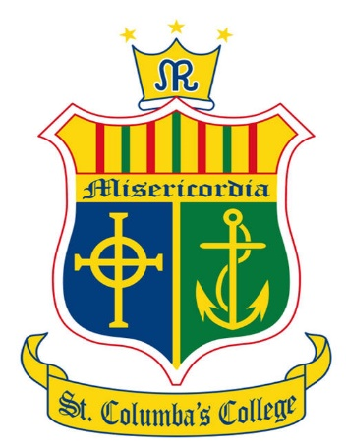
The Board of Management of
St. Columba’s College, Stranorlar
invites applications for the following post:
PRINCIPAL

To take effect from 1st September 2026
St. Columba’s College is a co-educational Catholic Secondary School in the trusteeship of CEIST and is conducted in accordance with CEIST Charter Values.
Current enrolment: 949 pupils.
The application form and further documentation may be obtained by download from
https://www.stcolumbascollege.ie
Completed typed application forms as a PDF attachment should be returned as an email to
tworecruitment@ceist.ie
Deadline for email and completed application forms:
Tuesday 5th May 2026 at 10am
Short-listing may apply.

The Board of Management is an equal opportunity employer.

*Provisional date for interviews: Week of 25th May 2026

This appointment is subject to sanction by the Department of Education and Youth

